DC Motors
  - Key Revision Facts: GCSE Science

An electrical motors converts direct current electrical energy into mechanical energy.
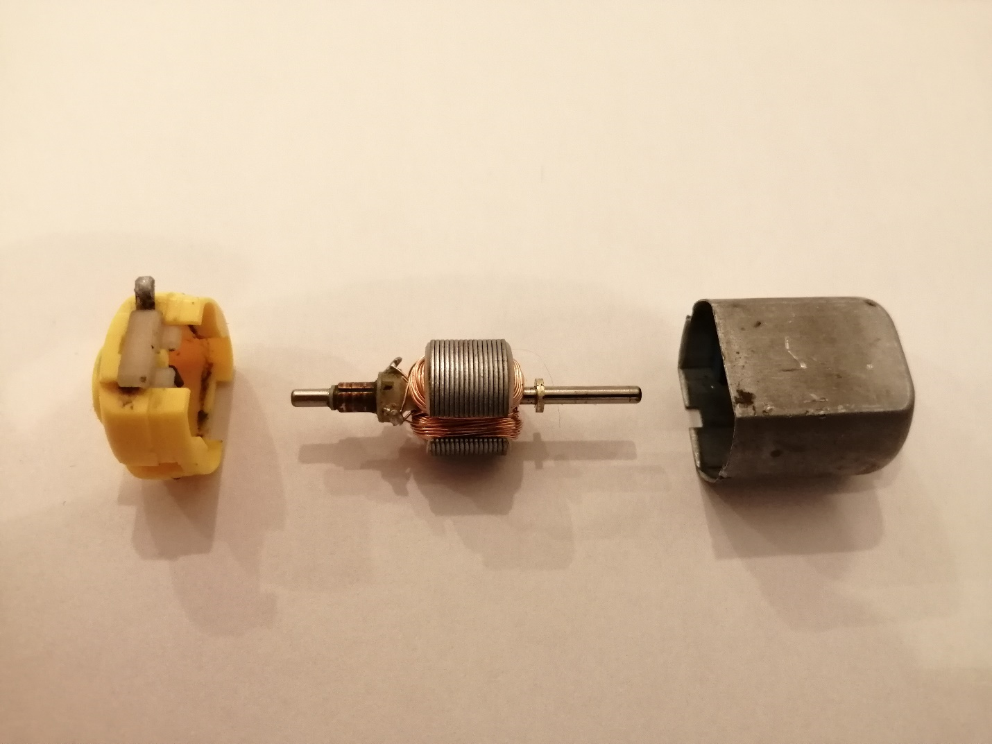
Iron Core

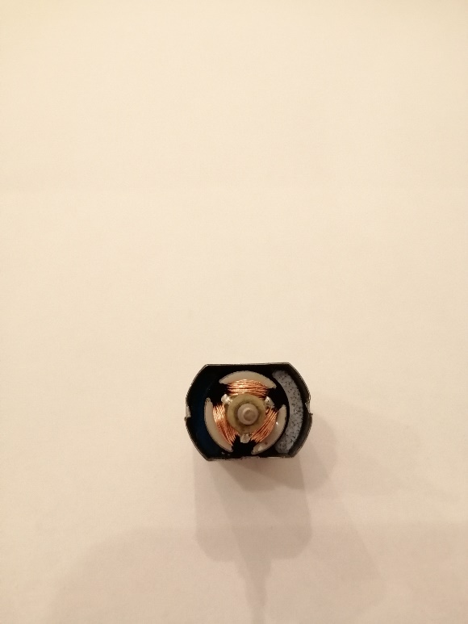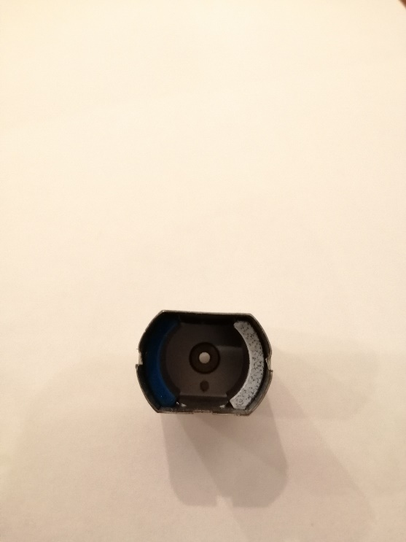
Windings
commutator
armature
Stator
A simple DC motor has a stationary set of magnets in the stator and an armature with one or more windings of insulated wire wrapped around a soft iron core that concentrates the magnetic field. The windings of insulated wire are connected to a commutator (a rotary electrical switch), that applies an electrical current to the windings. The commutator allows each armature coil to be energised in turn, the electromagnet generated by the coil of the armature is repled from stationary magnets in the stator, creating a steady rotating force.

